EMPLOYEE LEAVE MANAGEMENT SYSTEM

A Mini Project Report
Submitted in partial fulfillment of the requirements for the award of the degree of
Bachelor of Technology
In
Artificial Intelligence & Data Science

Submitted By
Team Members
- T.Munikarthik (23AK1A3063)
- A.Sasidhar (23AK1A3097)
- P.Pavan (23AK1A3072)

Department of Artificial Intelligence & Data Science
Annamacharya Institute of Technology & Sciences
Tirupati, Andhra Pradesh
Academic Year: 2025–2026

The Employee Leave Management System is a web-based application developed to simplify the process of applying for and managing employee leave requests. In many organizations, leave management is performed manually using paper forms or spreadsheets, which often leads to delays, data loss, and inefficient record keeping.

This project provides a digital solution where employees can submit leave requests by entering their details, selecting the leave type, specifying leave dates, and providing a reason for the leave. All leave requests are securely stored in a SQLite database.

The system also includes an administrator module that allows authorized personnel to view all leave requests, approve or reject applications, and monitor leave statistics through a simple dashboard. The dashboard displays the total number of leave requests along with pending, approved, and rejected requests.

The project is developed using Python, Streamlit, SQLite, and Pandas, making it lightweight, easy to use, and suitable for educational purposes as well as small organizations. The system reduces manual effort, improves transparency, and ensures better management of employee leave records.

1. INTRODUCTION
Employee leave management is an important function in every organization. It helps organizations maintain employee attendance records and manage leave requests efficiently. Traditional leave management methods rely on paper forms, emails, or spreadsheets, making the process time-consuming and difficult to manage.
The Employee Leave Management System is designed to automate the leave application and approval process through a simple web-based application. Employees can submit leave requests by entering their personal details, department, leave type, leave duration, and reason for leave. The submitted requests are stored securely in a database.
Administrators can access the dashboard to view all leave requests, monitor leave statistics, and approve or reject applications. This digital approach reduces paperwork, improves accuracy, minimizes human errors, and increases transparency between employees and management.
The project is developed using Python, Streamlit, SQLite, and Pandas, providing a lightweight, user-friendly, and efficient leave management solution.

2. PROBLEM STATEMENT
Many small organizations and educational institutions still manage employee leave manually. This approach creates several challenges:
- Time-consuming leave approval process.
- Difficulty maintaining paper records.
- High risk of losing employee leave data.
- Lack of transparency in leave approval.
- Human errors while updating records.
- Difficulty generating reports and statistics.
The Employee Leave Management System addresses these issues by providing an automated platform that stores leave information digitally and allows quick approval or rejection of requests.

3. OBJECTIVES
The primary objectives of the Employee Leave Management System are:
- To automate the employee leave management process.
- To eliminate manual paperwork.
- To allow employees to submit leave requests online.
- To enable administrators to approve or reject leave requests.
- To securely store leave records in a database.
- To improve efficiency and transparency.
- To provide an easy-to-use and user-friendly interface.
- To generate simple leave statistics for better monitoring.

4. LITERATURE SURVEY
Employee Leave Management Systems have become an essential part of modern Human Resource Management (HRM). Various organizations use digital systems to simplify leave applications, approval workflows, and employee record management.
Existing leave management applications developed by leading HR software providers include features such as leave balance tracking, automated notifications, role-based access control, and cloud storage. However, many of these systems are expensive and contain features that are unnecessary for small organizations or educational institutions.
The proposed Employee Leave Management System focuses on providing the core functionalities required for efficient leave management. It is lightweight, easy to deploy, and developed using open-source technologies including Python, Streamlit, SQLite, and Pandas. This makes the system suitable for academic projects, startups, and small businesses while maintaining simplicity and reliability.

PAGE 6 – EXISTING SYSTEM, PROPOSED SYSTEM & SYSTEM ARCHITECTURE
5. EXISTING SYSTEM
The traditional leave management process is mostly manual. Employees submit leave requests using paper forms or emails, and administrators maintain records manually. This process is inefficient and prone to errors.
Disadvantages of Existing System
- Manual paperwork.
- Time-consuming approval process.
- Risk of data loss.
- Difficult to maintain records.
- No centralized database.
- Lack of real-time tracking.

6. PROPOSED SYSTEM
The proposed Employee Leave Management System automates the leave application and approval process through a web-based application. Employees can apply for leave online, while administrators can manage all requests from a single dashboard.
Advantages of Proposed System
- Easy leave application process.
- Digital storage of records.
- Fast approval or rejection.
- User-friendly interface.
- Reduced paperwork.
- Better transparency.
- Efficient leave management.

7. SYSTEM ARCHITECTURE
The architecture of the Employee Leave Management System consists of three main components:
Employee Interface
- Employees submit leave requests using a simple Streamlit-based web interface.
Application Layer
- Python processes user input, validates data, and communicates with the database.
Database Layer
- SQLite stores employee leave details and status information securely.
Workflow
Employee
↓
Enter Leave Details
↓
Submit Leave Request
↓
SQLite Database
↓
Admin Dashboard
↓
Approve / Reject Request
↓
Updated Leave Status

8. SOFTWARE REQUIREMENTS
Hardware Requirements
- Processor: Intel Core i3 or higher
- RAM: 4 GB or above
- Storage: 500 MB free space
- Operating System: Windows 10/11
Software Requirements
- Python 3.x
- Streamlit
- SQLite
- Pandas
- Visual Studio Code
- Git & GitHub

9. MODULES DESCRIPTION
1. Employee Module
This module allows employees to submit leave requests by entering their personal details, department, leave type, leave duration, and reason. The submitted information is stored in the SQLite database with a default status of Pending.
Features
- Apply for leave
- Select department
- Select leave type
- Choose leave dates
- Enter reason
- Submit request

2. Admin Module
The Admin Module allows administrators to monitor all leave requests through a dashboard. Administrators can view records, approve or reject leave requests, and monitor leave statistics.
Features
- View all leave requests
- Dashboard statistics
- Approve leave
- Reject leave
- Update leave status
- Track employee leave records

10. IMPLEMENTATION
The Employee Leave Management System was developed using Python and Streamlit to provide a simple and interactive web interface. SQLite is used as the backend database to store employee leave details securely.
The application consists of two main sections:
Employee Module
- Employees enter their name, department, leave type, leave dates, and reason for leave.
- The leave request is stored in the SQLite database with a default status of Pending.
Admin Module
- The administrator can view all leave requests in a tabular format.
- Dashboard statistics display the total number of leave requests along with Pending, Approved, and Rejected requests.
- The administrator can approve or reject leave requests, and the database updates the status instantly.

11. DATABASE DESIGN
The system uses a single SQLite table named leaves.
Field Name | Data Type | Description
id | INTEGER | Primary Key
employee_name | TEXT | Employee Name
department | TEXT | Department
leave_type | TEXT | Type of Leave
start_date | TEXT | Leave Start Date
end_date | TEXT | Leave End Date
reason | TEXT | Reason for Leave
status | TEXT | Pending / Approved / Rejected

12. RESULTS
The Employee Leave Management System was successfully developed and tested. The application performs all the intended operations efficiently.
The system successfully:
- Accepts employee leave requests.
- Stores leave information securely in SQLite.
- Displays all leave records in a dashboard.
- Allows administrators to approve or reject leave requests.
- Updates leave status instantly.
- Displays dashboard statistics for better monitoring.
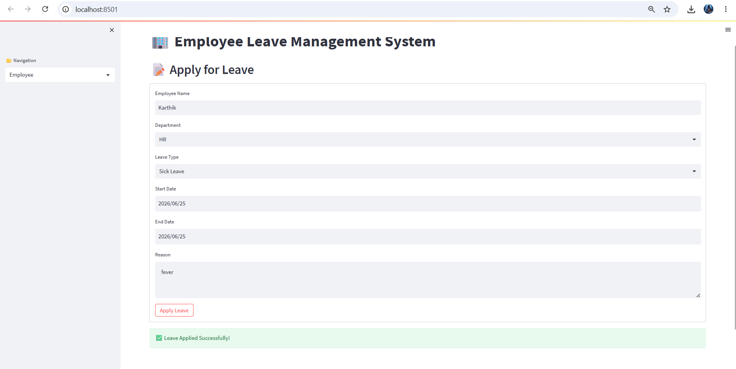

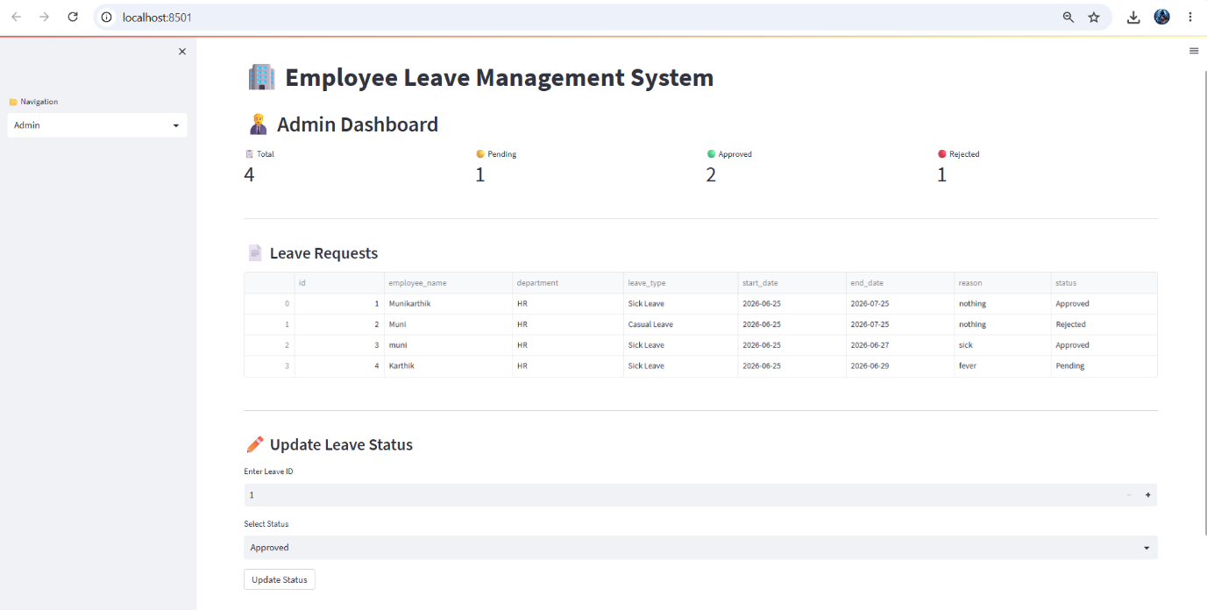

13. ADVANTAGES
- Easy to use interface.
- Eliminates manual paperwork.
- Faster leave approval process.
- Secure storage of employee records.
- Reduces human errors.
- Centralized leave management.
- Improves transparency.
- Lightweight and cost-effective.

14. LIMITATIONS
- No user authentication.
- No email notification system.
- No leave balance calculation.
- Supports only a single administrator.
- Uses SQLite, which is suitable for small-scale applications.

